Computer Systems

# Assignment-01(Alarm Clock)

Name: Kayes Ahmed Koushik

Student ID: 103832293

## Introduction:

We were required to use Logisim to create an alarm clock for this assignment. My computer is equipped with the Logisim program, so I started creating an alarm clock with it.

## Step-1: Making Counters for Minutes:

Four j-k flip flops were used to create a ripple counter, and its output was then routed to four D-flip flops so that the outputs could be recorded. Next, I created a splitter with the configuration Bit width in 4 and fan out 4. In the splitter, I serially connected the outputs to the inputs. After that, I attached a hexadecimal display to the splitter. Here, the reset output is 10.

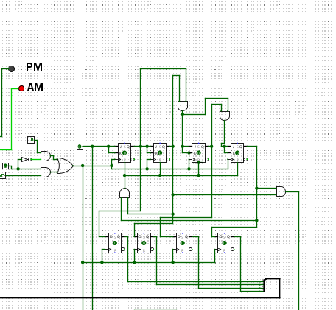

## Step-2: Making Counters for Minutes:

I created the identical ripple counter in the subsequent phase, but this time the reset output was Only after the first counter refreshes would this counter start to increase.

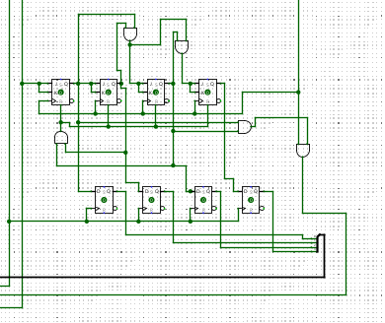

**Description of the circuit:**

The logic circuit is generally a digital alarm clock with numerous features, including the ability for the user to set an alarm and change the time.

**Conclusion:**

So far, I have done the clock only which is running perfectly and the rest of the part, Set Alarm I couldn’t figure out. And that’s why I have t done only this Clock part.

